Welcome to Lafayette County 4-H Updates – week of October 6, 2021
Please use the “quick links” below to go directly to the article of interest.
This newsletter is sent to “all” 4-H families in Lafayette County.
This update will come to your email inbox 2 times per month.

- The WI 4-H Website
- 4-H FAQ Related to COVID-19
- 4-H Guidance for COVID Activities (up to date)
- Virtual 4-H Learning Communities
- Lafayette County 4-H Annual Leader Banquet – October 17, 2021
- Lafayette County 4-H Trip & Award Materials found online
- Join the WI 4-H Leadership Committee – Youth Wanted!!
- JOANN Stores Discount Save 15% with JOANN 4-H Rewards!
- WI 4-H Fall Forum – Registration Deadline 10/10/2021
- 4-H Leader’s Upcoming Meeting Dates
- Lafayette County Steer Weigh-ins

Visit The Wisconsin 4-H Website
It’s new! It’s full of information! Find it at this link! https://4h.extension.wisc.edu/

4-H FAQs Related to COVID-19
This FAQ is also available on the Wisconsin 4-H website at: https://4h.extension.wisc.edu/4-h-faqs-related-to-covid-19/

4-H Guidance for COVID activities (as of 8-5-2021)
Program Guidance Update from the Wisconsin 4-H Program and Positive Youth Development Institute:
- Updated Guidelines can be found at: https://4h.extension.wisc.edu/wisconsin-4-h-covid-19-policy/
- When there is more restrictive local guidance, follow that rather than state 4-H guidance.

Virtual Learning Community Sessions
Check out the Virtual Learning Community! The Virtual Learning Community is a group of staff, volunteers, and youth members from across the state that are working to provide high quality virtual learning opportunities to people all across Wisconsin. You can find the Wisconsin 4-H Virtual Learning Community and check out their calendar at https://4h.extension.wisc.edu/virtual-learning-community/
You’ll register using your family “member list” in 4-H Online. . . more virtual opportunities will be available this fall! Bookmark the site for easy use.

Wisconsin 4-H Needs YOU! Applications NOW Available for WLC
Are you interested in building leadership in others? Do you enjoy planning and organizing? Do you get excited about working with a team of youth and adults to make a difference?
Have you served on or chaired county committees…been a county Ambassador…youth leader…adult mentor…taught countywide workshops…served as a camp counselor…been on Teen Court…worked with afterschool programs…worked on a team of youth and adults to plan workshops????
If you said YES, then you may want to consider applying to be on the Wisconsin 4-H Leadership Council. This may be an experience you would enjoy and you could contribute on a statewide level. Use the link below to find out more information.
https://4h.extension.wisc.edu/2021/08/18/wisconsin-4-h-needs-you-applications-now-available-for-wlc/

JOANN Stores Discount Save 15% with JOANN 4-H Rewards!
Current & lifetime members, parents of members, volunteers and 4-H staff can save 15% off total in-store and online purchases every day with 4-H Rewards. JOANN will give a minimum of 2.5% of every eligible transaction to support 4-H programming.

Save the Date: November 6, 2021 – Fall Forum!
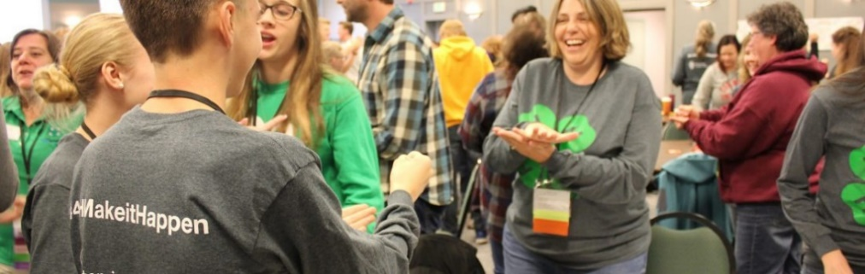
We’re excited to meet with youth leaders and adult volunteers throughout the state for a one day face-to-face Fall Forum.
We would love to have youth leaders, adult volunteers plan and lead sessions.
Things to Know:
The conference is VIRTUAL
Registration opens in 4HOnline on Friday, September 17, and closes Sunday, October 10. Cost is $30
Cost should not be a barrier to attending this program. If you would like a scholarship to cover Fall Forum fees, please complete this form or contact Laura Pine, lpine@wisc.edu or (608)262-1222.
Our hope is that 4-H youth leaders, adult volunteers, and staff will come together to connect, collaborate, celebrate, and continue building excitement and energy for a new year of 4-H learning!

Lafayette County 4-H Leader’s Banquet – October 17, 2021

Please join us at the Darlington Multipurpose Building on October 17 at 6:00 p.m. for our annual Leaders Recognition! We have several award winners and would like to recognize all of our 4-H Volunteer Leaders, as well as some outstanding 4-H youth, as well as our 4-H Ambassadors.
4-H Leaders Meeting will be on October 17th .
Here is a tentative list of remaining dates for Leader’s Meetings in 2021 and 2022.
November 21, 2021
February 20, 2022
April 17, 2022
June 19, 2022
August 21, 2022
September 25, 2022
November 20, 2022
Location(s) will be determined closer to the meeting dates.

4-H WEEK Celebration
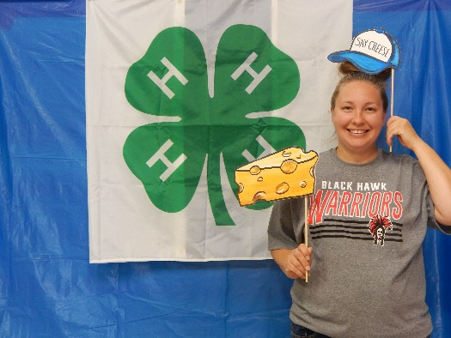
Kuddos to all of the 4-H members who visited the 4-H Day Celebration at the fairgrounds on September 26th. It was a fun day! Thanks to the 4-H Ambassadors and the Leader’s for the donation of time and food!! Thanks also to the Lafayette County Dairy Promotion Committee for sponsoring our ice cream treats!
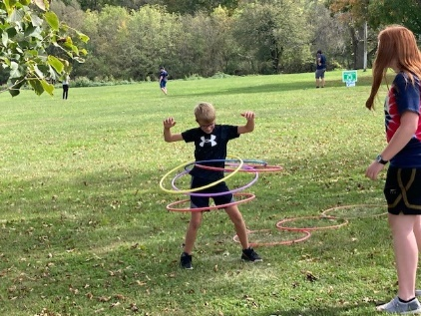
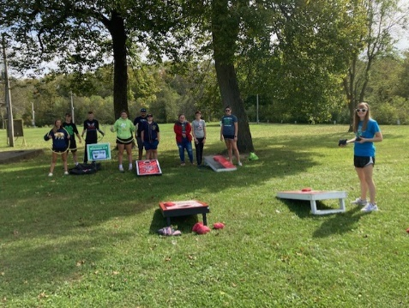

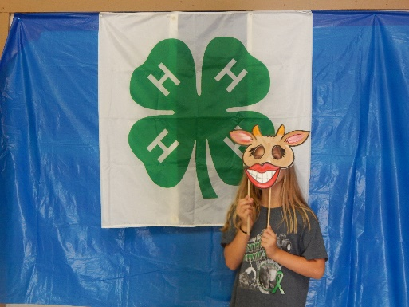
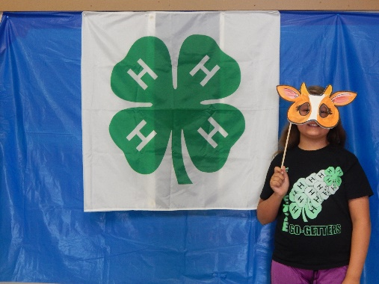
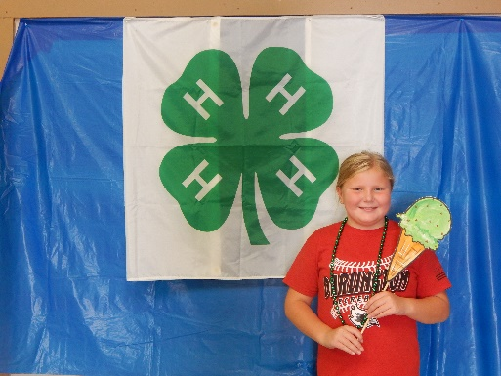
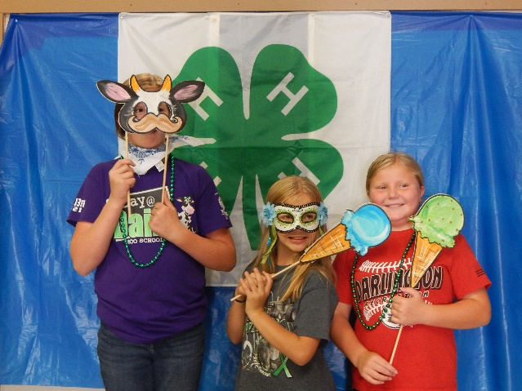
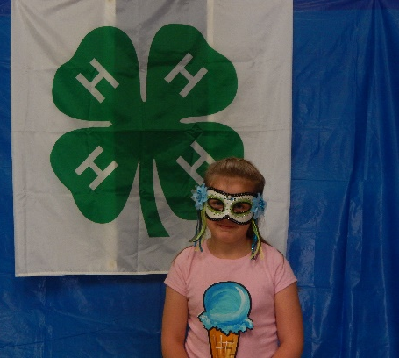

4-H Week . . . the beginning of a lifetime of opportunities!
Have you ever wondered what that green and white 4-leaf clover stands for? The one with four H’s on it? It represents the National 4-H Organization, which began in 1902 in Clark County, OH. The headquarters for 4-H is in Chevy Chase Maryland, and it is a federal governmental program administered through the Land-grant university system in each state and territory. Wisconsin’s Land-grant college (UW Madison) started hosting 4-H programs in 1914. T.L. Bewick was appointed Wisconsin’s first State 4-H Club Leader. All 72 Counties in Wisconsin sport 4-H Clubs, and Lafayette County currently as 10 Community Clubs, 1 Family Club, 333 youth members and 68 Adult Volunteers. The motto: “to make the best better” and the mission “engaging youth to reach their fullest potential while advancing the field of youth development”.
What has 4-H brought to our youth? 4-H Ambassadors share their insights on being a 4-H member in Lafayette County:
If I could do something over “retake” in 4-H it would be: “’Become an officer in our 4-H club. I recently joined the FFA officer team and regret not doing it in 4-H”.
Helping young 4-H members is fulfilling to me because: “I enjoy knowing I am helping to give younger members similar experiences as what I got as a young member. I have so many great memories in 4-H and it is nice to know I am providing other with those experiences and memories as well”.
My favorite 4-H project(s) are: “Showing dairy heifers because I enjoy working with animals, meeting new people and learning things about my heifers. I also enjoy taming the heifers down so they are friendly cows”.
One thing I would share with other about 4-H is: “4-H is a great way to get involved and meet new people. I really enjoy being in 4-H and being an Ambassador. As an Ambassador, I do a lot of things ‘behind the scenes’. My favorite part of being an Ambassador is helping the week of the Lafayette County Fair”.
Lafayette County 4-H is served by an Ambassador Team, which meets a few times during the year, to plan activities on a county-wide level for members. The team also finds a community service project to involve all 4-H members.
Lafayette County 4-H Ambassador Team:
Brody Cooper – Wiota Happy Hour
Tomi & Zach Daly – Wiota Happy Hour
Rebecca Gill – Wiota Happy Hour
Mariah Kendall – Willow Springs
Olivia Kleiber – Willow Springs
Liam Lansing – Wiota Happy Hour
Lizzy Meylor – Willow Springs
Octavia & Rawson Meylor – Willow Springs
Lydia O’Dair – Fayette Go-Getters
Lexi Wonders – Wiota Happy Hour
Sam Turpin – Lamont Hustlers
Judith & Josie Meister – Wiota Happy Hour
Ella Woodworth – Dunbarton
Tabetha Rowe – Pleasant View
Maggie Wedig – Pleasant View

Lafayette County Market Steer Weigh-ins for 2022 Fair
Mark your calendar and plan to have your market steer at the Lafayette County fairgrounds on December 18, 2021 from 9:30 – Noon. The cost of each RFID tag is $3.00. Please also bring your premise ID with you.
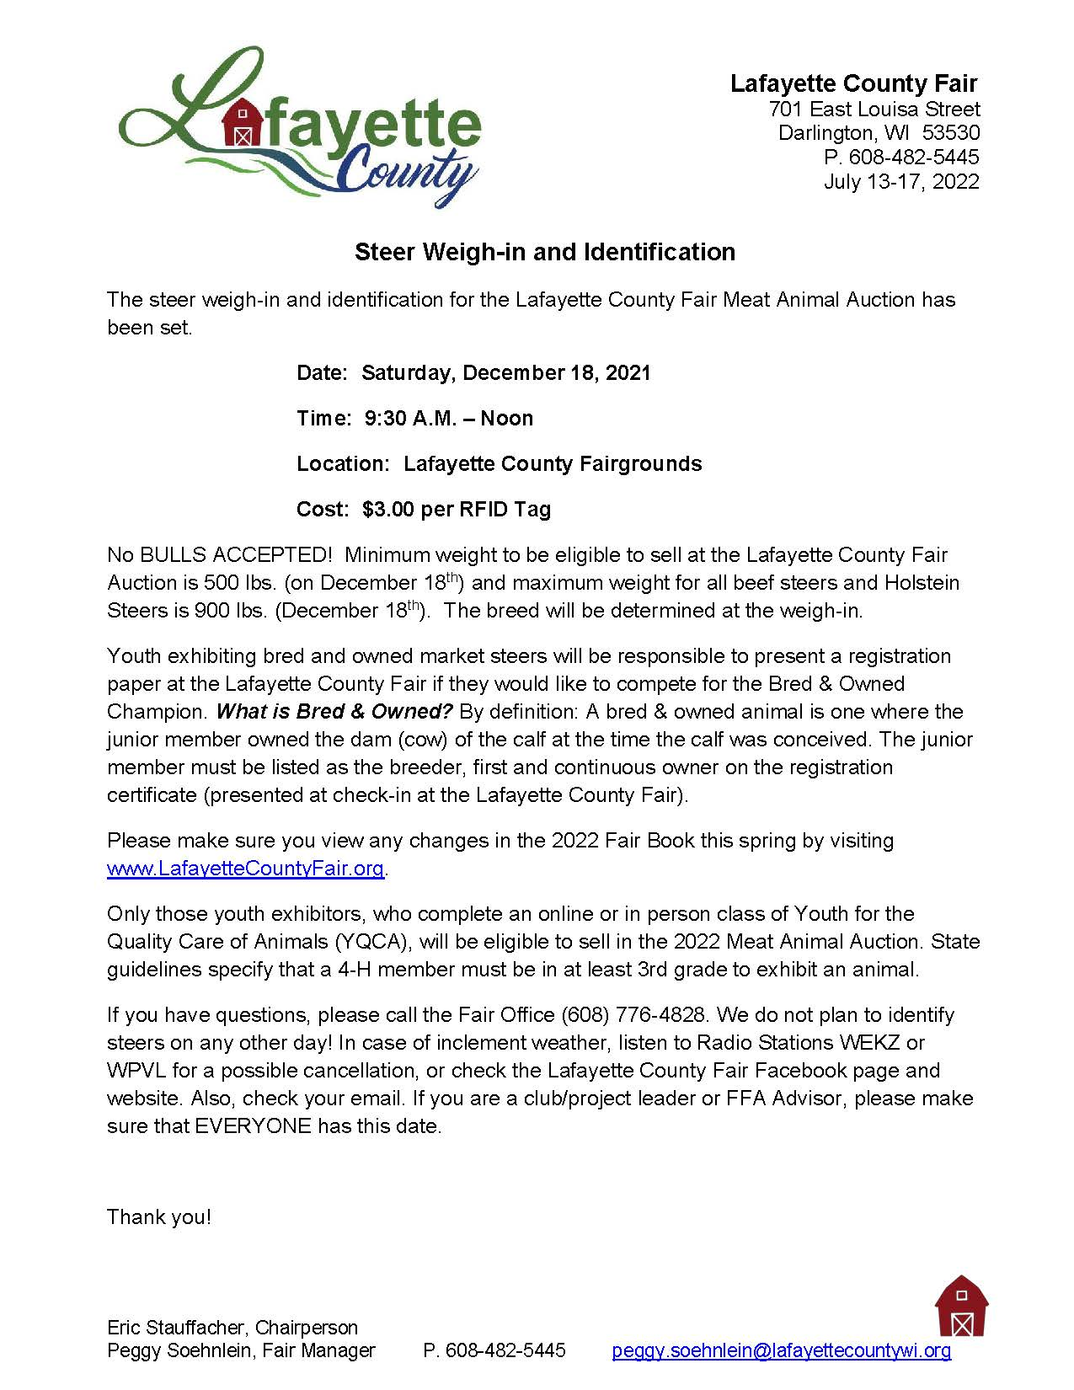

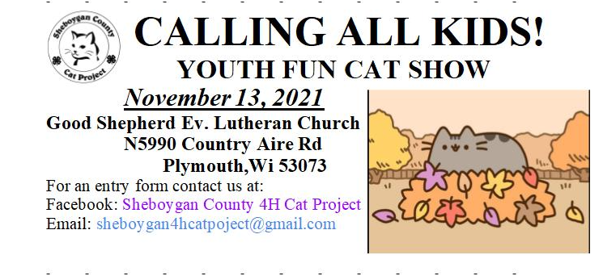

An

If you need to contact the Extension Office – Phone: (608) 776-4820
You can find us on the website: https://lafayette.extension.wisc.edu/

EEO/AA employer, University of Wisconsin-Madison Division of Extension provides equal opportunities in employment and programming, including Title VI, Title IX, the Americans with Disabilities Act (ADA) and Section 504 of the Rehabilitation Act requirements.

