Alfalfa Pest Management
Extension-Lafayette County

Field crop pests can be sorted into three main groups: weed, disease and insect. Depending on multiple factors including: heat, moisture and life cycles, these pests challenge agronomists and farmers a bit differently each year. Figure 1 is a triangle shaped illustration listing three main parts: environment, plant pest and crop host. Only when all parts are present is there risk of pest damage to a growing crop. Often, the environment corner of the triangle is the only remaining requirement needed for the risk of pest damage to increase.

In a perennial cropping system like alfalfa, the plants are susceptible to economic pest damage for a long period of time, often 3-6 years. Season long crop monitoring or scouting is a very important tool for ensuring a successful alfalfa crop this year and into the future. Many decisions which impact alfalfa pest management have already been made once an alfalfa stand is established. These decisions include: seed genetics, soil fertility, crop rotation/field selection, and establishment technique. The crops response to pest pressure and the pest management options available will be dependent on these decisions. Most alfalfa stands in a similar geographical area are subjected to similar pest pressure throughout the season.

Mid-season alfalfa pest management can bring pressure from all three of the main pest groups. According to NOAA, July 2020 is being forecasted as above normal for temperature and average for precipitation. Does this forecast suggest which alfalfa pests may be of greatest concern?
Insects:
This is a favorable environment for the development of potato leaf hopper (PLH). New seeding alfalfa fields are the most vulnerable, but all alfalfa fields should be scouted routinely. Extension recommends the following protocol to determine if PLH has exceeded the economic threshold: 1) use a 15” sweep net 2) sweep 20 times while moving across a small area of the field 3) count the PLH adults and nymphs present and record 4) repeat this in four additional locations travelling in a “W” shape across the field 5) refer to table 1 to determine if a control treatment would be beneficial.
Diseases:
A hot and dry environment will reduce the risk of alfalfa leaf and root diseases. A change in the weather forecast to cool and wet will increase the risk of leaf and root diseases in alfalfa.
Weeds:
Open canopy space in an alfalfa stand allows weed seeds an opportunity to germinate and grow. Plenty of sunlight and adequate moisture creates an environment for weeds from the weed seed soil bank to develop and cause pest damage. Often, these weeds are set back when the alfalfa is harvested and extensive damage doesn’t occur, but persistent weeds like waterhemp, quackgrass or even dandelion can lead to reduced alfalfa yield and limit stand longevity.

Alfalfa field crop pests can be managed successfully by using integrated pest management (IPM). Many of the tools available through IPM were discussed in this article. Timely crop pest updates and pest management information is available through the Wisconsin Pest Bulletin and the Wisconsin Crop Manager. Contact your local agronomist or county Extension office for additional details.

Resources:
http://datcpservices.wisconsin.gov/pb/index.jsp
https://ipcm.wisc.edu/downloads/wcm-files/
Table 1: Economic threshold of PLH in alfalfa
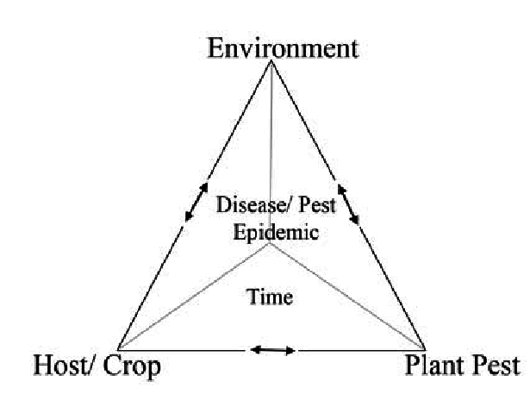
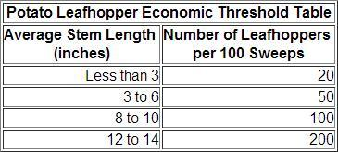
Figure 1: Field Crop Pest Management

diagram source: www.researchgate.net

