2020 Spring Seeded Cover Crop Trial

Abstract:
The cover crop establishment window in corn and soybean production systems in Wisconsin is limited during the growing season. Recommended strategies are available to assist with inter-seeding cover crops into growing grain crops. For these strategies to be successful, detailed planning, custom equipment and precise timing is often required. Cover crop establishment outside of the main growing season may serve as an ideal beginning point to implement a cover crop strategy on many farms. Early spring seeded cover crops may be a viable cover crop establishment option for many farms in Lafayette County.

Objectives:
1) Create a detailed description of cover crop characteristics
2) Identify the weed species present and document the growth characteristics observed
3) Measure the percent foliage cover of the soil ahead of cover crop termination
4) Measure the quantity of cover crop biomass produced during 60+ days of spring growth
5) Collect corn grain yield and quality data at harvest

Design:
The plot is designed to fit the field scale equipment used by the cooperating farmer. Each of the 12 plots measure 40x300 feet and are organized into three randomized replications. The four treatments being studied in this plot are as follows:
1. No cover crop
2. 56# Rye and 10# Red Clover
3. 32# Oats and 6# Radish
4. 56# Rye.

Timeline:
- March 16- frost seeded cover crops with no-till drill
- April 25- strip-tilled plot and applied fertilizer
- April 27- planted corn and applied fertilizer
- June- post emergence herbicide application
- July- side-dress N
- August- fungicide application
- October- harvest corn grain

Details:
Cover crop selection is an important part of the cropping plan. Understanding the growth characteristics of cover crops planted in early spring including: germination timing, foliage and root growth and the growth response of corn ahead of cover crop termination is being documented in this study. Cover crops are selected to provide a positive response to the cropping system. The responses being studied in this trial are weed control, soil cover and nutrient recovery through biomass production. Grain yield and quality is a major portion of final farm profitability for grain cropping systems. The final grain yield related to each cover crop practice will be measured and recorded. Economic and environmental values specific to implementing cover crops are difficult to define. The data being collected in this study will begin to explain the potential value of cover crops to a cropping system through root growth, soil cover, nutrient recovery and weed control. Additional site years of research and State Specialist support will be critical to better define these perceived values that are difficult to measure. Figure 1 on the back details the data collection protocol for this trial.

Figure 1. Data collection protocol
Data | Collection
1. Establishment characteristics | Bi-weekly notes/pictures of plants
2. Identify weed species/density | Bi-weekly weed counts
3. Estimate percent foliage cover | Phone app using picture image
4. Measure the quantity of biomass | Cut/weigh samples at termination
5. Collect corn grain yield data | BPA- yield monitor/weigh wagon

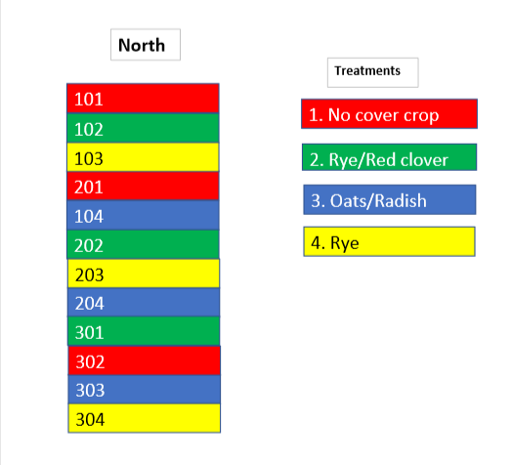
Plot layout

Additional information is available upon request from Extension-Lafayette County. Please call the Extension office at 608-776-4820 or send an email to joshua.kamps@wisc.edu to request information. Plot updates during the growing season can be found at lafayette.extension.wisc.edu/agriculture under the soil and water quality page. A final report will be posted at this location following fall grain harvest.

Do you have a soil or crop research idea? Contact Josh Kamps, Extension-Lafayette County to discuss the idea! Farmers must be part of directing Extension research efforts for the results to remain relevant and impactful! Thank you for visiting the drive-thru cover crop plot today!

