February 22, 2019

Annually, Lafayette County Extension, a division of the University of Wisconsin-Madison, takes steps to assure our partners know and understand our policy of nondiscrimination. This letter is to remind or notify you the University of Wisconsin-Extension does not discriminate in the treatment of individuals, in admission or access to its programs and activities, in the provision of services, or in employment.
Further, UW-Extension, an institution receiving federal financial assistance through the U.S. Department of Agriculture, cannot participate with or partner with organizations that discriminate on the basis of any of the legally prohibited categories of discrimination, based on Civil Rights laws. Categories of prohibited discrimination include race, color, gender/sex, creed, disability, religion, national origin, ancestry, age, sexual orientation, pregnancy, marital or parental status, arrest or conviction record, or membership in the national guard, state defense force or any other reserve component of the military service.
To help us ensure that our partners do not discriminate, we request an officer of your organization sign and return the enclosed form and attach a copy of the nondiscrimination policy of your organization if it has changed since last year.
Consistent with the Americans With Disabilities Act, persons who need materials in alternative format or other accommodations are encouraged to write, email or call the UW-Extension contact person for the specific program or call the main telephone number of the UW-Extension Lafayette County Office, (608) 776-4820, as early as possible prior to the event so appropriate arrangements can be made. Requests are kept confidential. Individuals who need special access due to hearing impairment may contact the UW-Extension Lafayette County Office by calling the relay service for the hearing impaired by dialing 711.
We want to thank you for collaborating with UW-Extension on educational programs. We appreciate your support and partnership, as we provide education and programs designed to meet the needs of the diverse residents of Lafayette County.
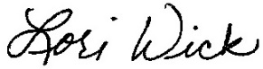
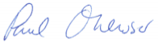
Sincerely,

Paul Ohlrogge Lori Wick
Area Extension Director 4-H Youth Development Educator
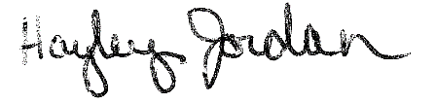

Josh Kamps
Hayley Jordan Josh Kamps
Health and Well Being Educator Agriculture Educator

"An EEO/AA employer, University of Wisconsin-Extension provides equal opportunities in employment and programming, including Title IX and ADA requirements. Please make requests for reasonable accommodations to ensure equal access to educational programs as early as possible preceding the scheduled program, service or activity."

